**Assignment – 4**

**Language:** Python 3.5.2

**Description:** In this assignment I have implemented connect-4, the screenshots show how the game is played between a human and a computer(AI). First the Human gets to choose either ‘X’ or ‘O’ and the computer is given the other option, Randomly the game choses either human/computer to go first, then the game will end until there is a winner or a tie.

AI is implemented in such a way that it calculates the best move (potential moves) before playing the actual game and once the AI decides whether the best moves then only the move is placed, so always the AI wins with the best moves unless the human is too intelligent to equal the AI.

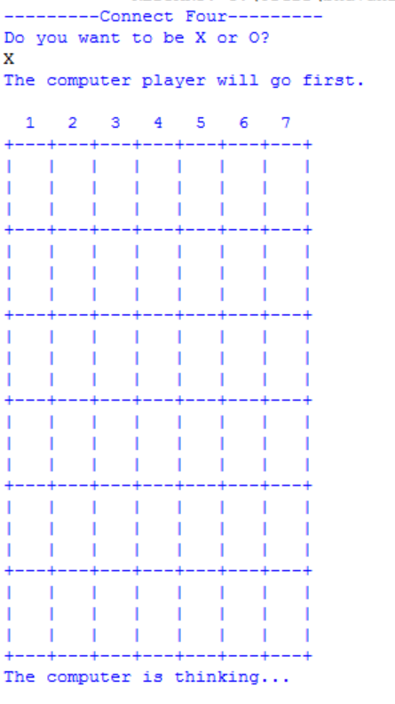**Program:**  You can download the .py file and run in IDLE directly.

**Sample Output:**

